Protein and DNA

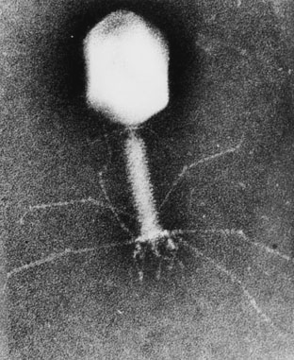

DNA is composed of 2’-deoxy-nucleotides carrying the bases adenine (A), guanine (G), cytosine (C) and thymine (T). The molar mass of the 2’-deoxy-nucleotide-5’-triphosphates is given in table 2:

Table 2  dNTP | Molar mass /g mol^{–1}
dATP | 487
dGTP | 503
dCTP | 464
dTTP | 478

- Calculate the molar mass of a double stranded DNA fragment consisting of 1000 base pairs with a uniform distribution of the four bases.

This DNA fragment can be isolated and cloned by using the PCR method (polymerase chain reaction), in which a heat stable DNA polymerase enzyme multiplies the number of molecules of a specific piece of DNA in a cyclic process. Under optimal conditions the number of double-stranded DNA copies doubles in each cycle.

Using the PCR method you perform 30 cycles starting from a single double stranded DNA molecule.

- Calculate the approximate mass of the DNA you obtain from this experiment.

The bacteria-virus T4 enzyme - polynucleotide kinase (PNK) catalyzes the transfer of the terminal phosphate of ATP (γ-orthophosphate) to the 5'-hydroxyl termini of ribo- and deoxyribonucleotides:

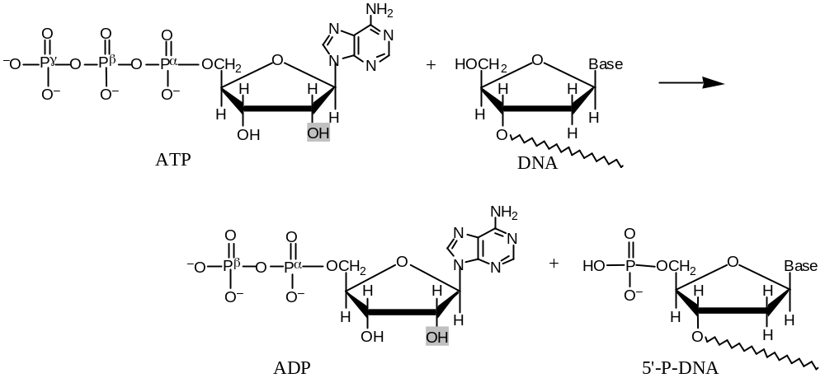

PNK is commonly used to label DNA at the 5’-end with the radioactive phosphorus isotope ³²P using ATP in which the γ-P (the outermost of the phosphorus atoms) is replaced with ³²P. The amount of ³²P and thus the amount of labelled DNA can be measured.

A 10 µL solution containing double stranded DNA is labelled 100% with [γ-³²P]ATP by PNK. 37 days ago, the specific activity of [γ-³²P]ATP was 10 Ci/mmol or 370 ·10⁹ Bq/mmol. ³²P has a half-life of 14.2 days, and during the decay a β-particle is emitted. Now the labelled DNA emits 40000 β-particles/s.

- Calculate the concentration of the DNA solution.

In an experiment in which PNK is incubated with [γ-³²P]ATP and single stranded DNA, the reaction can be monitored by isolating labeled DNA and measuring the β-particle emission.

Using this kind of measurements in a 1 mL experimental mixture, a labeling of
9 nmol DNA/min was calculated. PNK has a catalytic rate constant (turnover number) of 0.05 s^{–1} and molar mass of 34620 g mol^{–1}.

- Calculate the concentration (in mg/mL) of PNK in the experimental mixture.

Aromatic amino acids, tryptophan, tyrosine and phenylalanine absorb UV light of a wavelength between 240 nm and 300 nm.

In a protein containing several aromatic amino acids, the sum of the molar absorptivity per amino acid Σε_{amino acid}, is approximately equal to the molar absorptivity, ε_{protein} , for the protein.

The molar absorptivity, ε_{amino acid}, at 280 nm for tyrosine, tryptophan and phenylalanine is 1400 m^{–1} cm^{–1}, 5600 m^{–1} cm^{–1} and 5 m^{–1} cm^{–1}, respectively. The absorbance of a 10 µm solution of PNK is 0.644 at 280 nm and with 1.00 cm light path. The amino acid sequence of PNK contains 14 tyrosines and 9 phenylalanines.

- Calculate the number of tryptophan residues in a PNK molecule.

